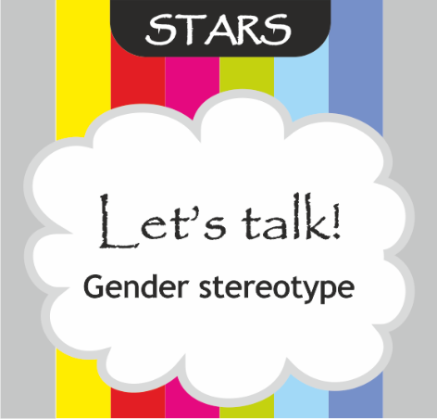
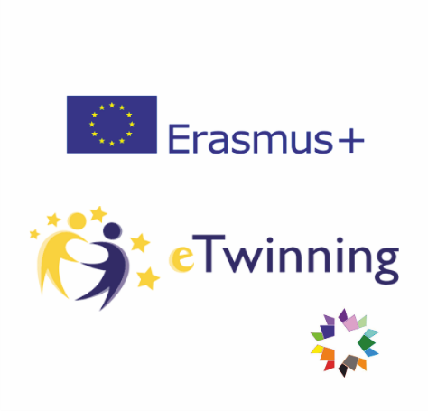

CONTENTS
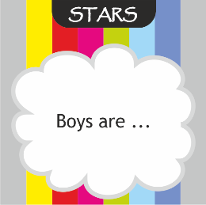
- 48 „finish the sentence“ cards for starting a conversation and expressing opinions on gender stereotypes

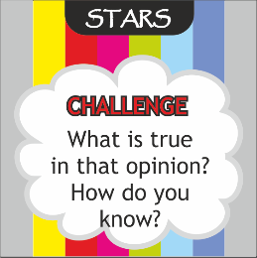
- 15 challenge cards
- 6 Let's talk!question cards
- 1 card – the title

PURPOSE
A conversationand opinion – challenging game on the topic of gender stereotypes with the purpose of encouraging and developing tolearnce towards differences.
Age: 9+

PREPARATION
- CHALLENGE CARDS
Mix the challenge cards, including the 4 challenge cards containing question marks. The person who has the card with the question mark can ask their own question for challengin someone's opinion. The question should be challenging, but must not be offensive. If you decide that asking their own questions is too challenging for the group, you can omit the cards with question marks. Give the cards to 5 people. Each person gets 3 cards with questions.
IMPORTANT!
At the beginning we go through all the challenge cards with the students and give specific examples when and how the questions can be asked.

Example:
Boys shouldn't wear make-up.

When is that not true? When do boys wear make-up?
What would you say if you were a boy who liked wearing make-up or has acne so he wants to cover them?
Why do you think that? Why do you think boys shouldn't wear make-up? How did you come to that conclusion?

What is true about that? Is it true that boys shouldn't wear makeup? How do you know that?
Who wouldn't agree with you? Why?

Is it possible to have another opinion on that? Find an opposite example.
When is it appropriate for boys to wear makeup? What are the bigger consequences of your opinion?
How does your opinion affect others? How does your opinion affect your behaviour?
Does your opinion help you be a better person? Does it make you be more tolerant towards differences, more open-minded, etc.?
What would happen if you changed your opinion? Would that affect your behaviour? Would your behaviour change? How?
How would an alien comment on that? If we asked an alien from another galaxy say about boys wearing makeup? Would aliens agree or would they see it in another way? Would they relate wearing makeup to gender?

- „FINISH THE SENTENCE“ CARDS
Decide in advance whether you are going to use all the cards or just some of them.
Mix the cards which also contain 2 question mark cards, or mix only the chosen cards. If you use the cards with the question mark, then the person who gets it can make up his 7 her own beginning of the sentence and then finish it. Another option is that he / she starts the sentence and someone else has to finish it.

- Let's talk! CARDS
Separate those from the other cards. The teacher uses these cards as a reminder for a conversation. We use them when we want to talk some more about what we have learned about ourselves and the others.

Conversation questions

Some of the examples of conversation questions are:
- How similar or different are our answers?
- Who gave the answers most similar to ours?
- What have you learned or discovered about yourselves and the others?
- Did you question your own opinion? Which one?
- Have you recognized and challenged any of the stereotypes? Which ones?
- How has your tolerance towards differences increased?

INTRODUCTION: What are gender stereotypes?
Stereotypes are simplified images in our minds about men and women, girls and boys.
Stereotypes are beliefs which describe typical men and typical women and which we believe are true for all members of the male or female gender.
The beliefs can be connected to:
- Physical characteristics (e.g. physical appearance, strength, voice, physical abilities, etc. )
- Character ( e.g. ambitious, successful, compassionate, gentle, etc.)
- Carreer choice (the so called „female“ and „male“ jobs, school sublects, etc.)
- Emotional characteristics ( e.g. brave, weepy, etc.)
Gender roles are different beliefs and expectations that we have from men and women, which tell what men and women should be like, which behaviours are appropriate and which are not, male and female roles, etc.
As a consequence, there can be intolerance towards gender differences, towards differences or similarities within the same gender, which can make us judgemental and prone to exclusion, rejection, isolation of those who don't fulfill our expectations.
Due to the possible serious negative consequences of our beliefs, expectations and behaviour, it is crucial to re-examine our opinions and beliefs and develop tolerance towards differences.

INSTRUCTIONS

- EVERYBODY TALKS ABOUT THE SAME SUBJECT

We all form a circle (if possible).
One person draws a card, reads it out loud and finishes the sentence. The others finish the same sentence, but each ending has to be different than the others.

The persons with challenge cards decide amongst themselves who will ask a challenge question. The aim of challenge cards is for the person who has finished the sentence broadens his/her horizons, re-examines their opinion or breaks down a stereotype.

- TO EACH HIS/HER OWN!

One person draws a card, reads it out loud and finishes it. At this point a challenge question can be asked. If wanted, another challenge card can be read afterwards. The aim is for the person who has finished the sentence broadens his/her horizons, re-examines their opinions or breaks down a stereotype.
Zatim je na redu slijedeća osoba.

- CONVERSATION

After a person draws a card, we can all talk about it and use challenge cards to re-examine our beliefs, attitudes and expectations. After that challenge questions can be asked.

The teacher uses the Let's talk! cards to ask questions to the group in order to draw final conclusions.

Author: Snježana Pejnović

