

The Hindu Mandir

Introduction

The word “Mandir” comes from the Sanskrit word for “house” and it’s the correct name for a Hindu holy building, although most Hindus just call it a Temple. This lesson explores the main features of a Mandir, its main purpose as a home for the murtis (images) of Gods and Goddesses, and how all five senses are involved in Hindu worship.

There are a lot of potentially unfamiliar words in this lesson, so a pronunciation guide is provided at the start of the resources section on page 11.

The accompanying film was shot at the Shri Swaminarayan Mandir in Neasden, North London. There is a lot of useful information and some beautiful images on their website which you can find here:

http://www.mandir.org

Contents

Lesson Overview 2

Film Digest 3

Lesson Plan 4

Resources 10
Overview

Suitable for : Students aged up to 14.

Lesson Objectives: To learn the main features of a Hindu place of worship.
To learn how devotion is shown to the murtis.

Key Question: How do Hindus worship?

Time: 1 hour

TrueTube Film: Holy Cribs: The Mandir
Theme: Ethics and Religion
Topic: Religious Traditions

Resources: Internet connected whiteboard or enough PCs for the class.
Mandir Pronunciation Guide
A Traditional Mandir – Diagrams
Six Senses – Note-taking sheet
Visiting a Mandir – Information sheet
Shiva Nataraja – With questions
Shiva Nataraja – unlabelled
The Symbolism of Shiva Nataraja – Teacher notes
(Full list below)

Key Words: Mandir
Haveli
Deity
Murti
Shrine
Mandapa
Garbha Griha
Shikara
Puja
Prasad
Arti
Bhakti

Film Digest

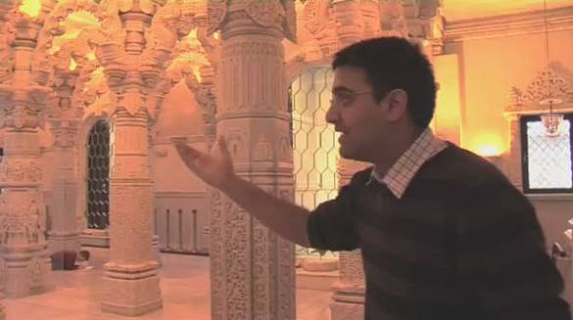 | Holy Cribs: The Mandir (10:14)  Theme: Ethics and Religion  Topic: Religious Traditions  Nirav gives TrueTube a tour of Shri Swaminarayan Mandir in North-West London, explaining its most important features and his beliefs as a Hindu.
Lesson Plan

 | Starter  As the students enter the classroom, make sure that each of their five senses is stimulated in some way, e.g. -  Sight A Hindu murti (if you have one) or a candle at the front of the room.  Hearing Soft instrumental music (very quiet – or the students will raise their voices to talk  over it).  Taste Allow each student to take a sweet to eat as they arrive (M&Ms, Skittles, Smarties - something small and inexpensive).  Smell Incense, flowers or fruit, or all three.  Touch Give those students who are willing a “tikka” mark on their foreheads (and if you have one on yours, it will help!) – use kumkum powder if you have it, or red powder paint. Mix it into a thick paste with a little water, or dip a finger into water and then into the powder before applying it to the forehead. |  | 5 mins
 | When your students are sat down and settled, ask them to write down how they have used each of their five senses – have the senses written on the board so you don’t have to keep reminding them. |  | 2 mins
 | Share the lesson objectives with the class, and explain the meaning of the key words: |  | 3 mins
 | Mandir  Haveli  Deity  Murti  Shrine  Mandapa | “House” - A Hindu Temple.  A hall or meeting room, often attached to a Mandir.  A god or goddess.  A statue of a Hindu deity.  A small area dedicated to a deity – usually containing a murti and offerings.  The main prayer hall of a Mandir.

 | Garbha Griha  Shikara  Puja  Prasad  Arti  Bhakti | “Womb house” – the most important shrine in a mandir.  A spire or tower above a shrine.  Prayer or worship.  Food that is offered to the murtis, blessed and then shared amongst the worshippers.  An offering of light to the deities.  “Devotion” – actions that Hindus perform to show their devotion to God.
 | Main Activities  Hand out copies of A Traditional Mandir to each student, so while they are watching the film, they can follow the tour on their sheets. The diagram is of a generic Mandir, but the one in the film is built along very similar lines.  Alternatively – and if you have time - you could give out blank copies of the Mandir diagrams and ask your students to label them as they watch the film.  Also hand out the Six Senses sheets. Ask your students to think about how each of the five senses are engaged by what happens at the Mandir, and jot down some ideas on the sheets. The “sixth sense” is anything else that the students think might be engaged by a visit to the Mandir – e.g. emotions, feelings, a sense of awe... |  | 1 min
 | Show the film Holy Cribs: The Mandir. |  | 10 mins
 | NOTE: the Mandir in the film belongs to a Hindu organisation that is dedicated to the teachings of Shri Swaminarayan who they believe is a form of the God Vishnu. In all other respects, this is a very traditional Mandir.
 | Now hand out the Visiting a Mandir sheets and in pairs, your students can add to their Six Senses notes: how are each of the artefacts used in worship, and which of the senses do they engage? How might the worship make people feel? |  | 5 mins
 | Get some feedback from the class.  Explain that each of the senses are engaged in Hindu worship to symbolise that the whole person, their whole life, should be devoted to God. Hindus show this devotion through their worship at the Mandir, and in the respect they show to the murtis. This devotion is called “Bhakti”. |  | 5 mins
 | If you have a puja tray, you could demonstrate how Hindus uses the various objects in their offerings to God:  Sight A ghee lamp or arti lamp to offer light to the murti. The light symbolises enlightenment.  Hearing A bell used to “awaken” the murti and bring people to worship.  Taste Offerings of fruit, nuts or sweets, which God blesses to become Prasad.  Smell Incense and flowers used to “purify” the air and create an atmosphere of worship.  Touch A water pot (called a kamandalu) and spoon used to wash the murti, a red powder called kumkum, and sandalwood paste used to anoint the murti and to make tilaka marks on the foreheads of worshippers. |  | 3 mins
 | Give out the Shiva Nataraja sheets. Two are provided in the Resources section below – one with questions for the students, and a blank one to display on the board (or you might prefer your students to label this one).  Display the blank picture of Shiva Nataraja, and if you have a Shiva Nataraja statue you can pass it (carefully!) around the desks so the class can get a closer look.  Explain that Hindus believe in one God – an unseen spirit called Brahman, and that all the different murtis are a way of explaining different aspects of Brahman’s character. The various symbols the images hold, the actions they perform, even their expressions all have a deeper symbolism. |  | 6 mins

Discuss with the class what they think the various symbols might mean – the easier ones are pointed out on the Shiva Nataraja sheets. You may well need to guide your students with some questions until they get the idea.

E.g. What do you think the water symbolises? What do we use water for? What would happen if we didn’t have any water?

Some of their answers may well surprise you with their depth! And fear not - there are some teacher guidance notes to help you in the Resources section below.

 | Ask your students to write a Sensory Tour of a Mandir. They should write an account of a visit to a mandir. Using their floorplans as a framework and their Six Senses sheets as a reminder, they should describe in the first person and in the present tense what they do and where they go in the mandir, and what they see, hear, touch, taste and smell at each stage. | 10 mins
 | Hear as many of the Sensory Tours as you have time for at the end of the lesson. | 5 mins
 | Plenary - Has Learning Taken Place?  Play Backs to the Board. It works like this...  - Get your students into pairs.  - Pick a pair: ask one student to sit on a chair with their back to the board, the other faces them with a clear view of the board.  - Write or display a word from the lesson on the board.  - The student facing the board has to describe the word without using it or any part of it and the student sitting in the chair has to try and guess what on earth they are talking about.  - Give them a time limit (say, a minute) to see how many words they can get through, then choose another pair to have a go.  - Award a prize to the winners – sweets, housepoints or merits – whatever is suitable in your school! | 5 mins

Extension - Suggested Further Activities

If you don’t have any Hindu artefacts, invest some of your RE budget in a puja tray, a murti of Shiva Nataraja, a murti of Ganesha and so on - they will help to bring the lesson alive, especially for kinaesthetic learners.

Visit a Mandir!

If you are within reach of London, a visit to the Shri Swaminarayan Mandir - where the film was shot - is well worth a day-trip. You can book online here:

http://www.mandir.org/booking/index.htm

If there is a Hindu community in your area, find someone who would be willing to come in to face some questions from your students.

To avoid an embarrassing silence, make sure that the students already have some questions prepared and have written them down. You might also like to nominate one or two of your more confident students to ask the first questions and get the ball rolling.

If you don’t have time to check all the questions beforehand, remind your students that the questions are written in their exercise books and you will see them. Set one simple ground rule: is it a question you could ask your granny (if she was a Hindu)?

Find pictures of other murtis and find out what the various symbols mean – the colours, the objects they hold, the way they stand or sit, and so on. Start with Ganesh, Vishnu, Lakshmi and Durga.

Find out about the traditional forms of Yoga – the ways in which Hindus try to attain union with God. Bhakti Yoga – trying to achieve union with God through devotion – is just one form. There are many disciplines, some of them quite modern, but the oldest and most respected are:

- Bhakti Yoga – Bhakti means “devotion” in Sanskrit. Hindus show devotion to a personal form of God, often Krishna.
- Karma Yoga - Karma means “action”. Hindus believe that God lives in all living things, and so by doing things for other people, they are actually serving God.
- Hatha Yoga - “Ha” means “sun” and “tha” means “moon”. Day and night are opposites that exist in balance, so this form of yoga is all about getting the balance right – literally. People bend themselves into different poses and positions to learn complete control of their bodies.
- Mantra Yoga - A “mantra” is a sound, word or a short phrase that Hindus use in meditation. It helps them to clear their heads of all worries and distractions so they can be still and at peace. They might repeat a prayer, or one of God’s names, or the holy word “Om”, or a phrase such as “Om Namah Shivaya” which means “I honour Shiva”. Some people like to use a string of beads called “mala” to help them concentrate. They pass the beads through their fingers to the rhythm of the words.
- Jnana Yoga - Jnana means “knowledge” or “wisdom”. This is a form of meditation in which Hindus use their minds to try and understand themselves and their relationship to God.
- Raja Yoga - Raja means “royal”. This type of yoga also uses meditation, similar to Jnana Yoga, but much harder because the aim is eventually to think about nothing at all.

Resources

- Mandir Pronunciation Guide

- A Traditional Mandir – Floorplan and side view - labelled and blank

- Five Senses – Note-taking sheet

- Visiting a Mandir – Information sheet

- Shiva Nataraja – With questions

- Shiva Nataraja – unlaballed

- The Symbolism of Shiva Nataraja – Teacher notes

You will also need:

- Items for the starter – a candle, incense, soft instrumental music, sweets, kumkum powder (or red powder paint), matches, water.

- Any Hindu artefacts you might have, e.g. a puja tray, a murti of Shiva Nataraja.

Mandir Pronunciation Guide

Due to the large number of potentially unfamiliar words, here’s a rough guide to their pronunciation.

Note that the pronunciations and the spellings of these words vary anyway depending on dialect and transliteration, so have go...

Apasmara Purusha  Ardhamandapa  Arti  Brahman  Brahmin  Bhakti  Durga  Ganesha  Ganga  Ganges  Garbha Griha  Garuda  Gopuram  Hatha  Haveli  Jnana  Kamandalu  Karma  Kumkum  Lakshmi  Mandapa  Mandir  Mantra  Murti  Nandi  Namah  Nataraja  Om  Pradakshina  Prasad  Puja  Pujari  Purohit  Raja  Sadhu  Shakti  Shikara  Shiva  Shivaya  Swami  Swaminarayan  Tikka  Tilaka  Vishnu | a-pas-mar-a per-roo-sha  are-da-mun-da-pa  are-tee  brar-mun  brar-min  buck-tee  derr-ger (short second syllable)  gun-nesh-a (sometimes said without the final “a”)  gan-ja  gan-jees  gar-buh gree-ha  ga-roo-der (short last syllable)  go-poor-um (“poor” is almost “pu-er”, not “pore”, but keep it short!)  ha-ta (the “ta” has a soft “t”, almost a “d” sound)  ha-vel-ee  jer-nar-na (the first syllable is very short)  cum-un-dar-loo  car-ma  kum-kum (! – short syllables to rhyme with “room”, not “mum”)  luck-shmee  mun-duppa (sometimes said without the final “a”)  mun-deer  mun-tra  moor-tee (“moor” is almost “mu-er”, not “more”)  nun-dee  nar-ma  na-tar-rar-ja (all short syllables)  aum - (difficult one this because when used in meditation the word is spread out over all the vowel sounds.  prud-uck-shee-na  pruss-ud (keep the first syllable short)  poo-juh  poo-jar-ee  poor-oh-hit (“poor” is almost “pu-er”, not “pore”, but keep it short!)  rar-ja  sud-doo  shuck-tee  shik-a-ra  she-va (sometimes pronounced “see-va”)  she-vay-a  swar-mee  swar-mee-na-rye-an  tick-a  til-lack-a  vish-noo

Mandir Floorplan

Mandapa
Pradakshina
Garbha Griha
Steps
Ardhamandapa
Bell
Shoe racks
Steps
Shrine to Ganesh
Money box for offerings
Pillars
Guardian

Flags
Shikara
Garbha Griha
Pradakshina
Mandapa
Ardhamandapa
Guardian
Bell
Facing towards the rising sun

Sight | 
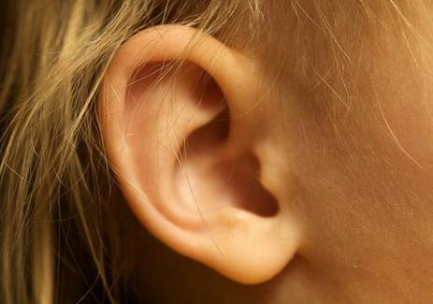 | Hearing
Smell | 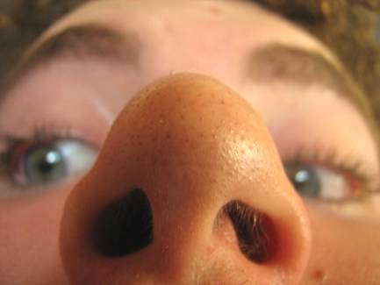
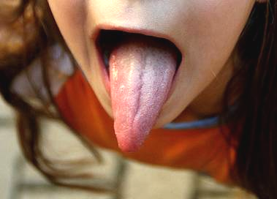 | Taste
Touch | 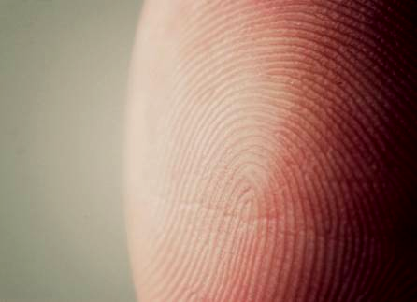
 | The Sixth Sense....
Pictures ©Flickr/storymary/Travis Isaacs/rq?/Phil Dragash/baymet/Fr Antunes
Visiting a Mandir

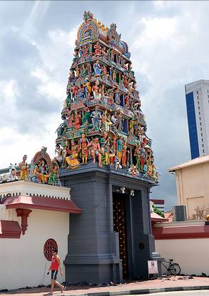  ©Flickr/PrettyKateMachine | Gopuram  The first thing visitors to a traditional mandir will see is a gopuram. This is a gateway or a tower, or a gateway with a tower, which marks the entrance to the temple grounds. Gopurams are often beautifully decorated with images of Hindu Gods and Goddesses, sometimes telling stories from the life of the deity that the mandir is dedicated to.  The word “mandir” comes from the Sanskrit word for “house” and so the temple is thought of as God’s home. The different parts have special meanings – often symbolising different parts of the body.
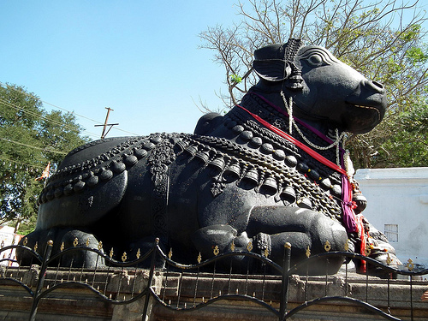  ©Flickr/Rameshng | The Guardian  Between the gopuram and the mandir itself there is often a statue of an animal which spiritually protects the shrines inside. Common guardians are Nandi the bull (who is associated with the God Shiva), and Garuda who is half man, half eagle (associated with the God Vishnu).
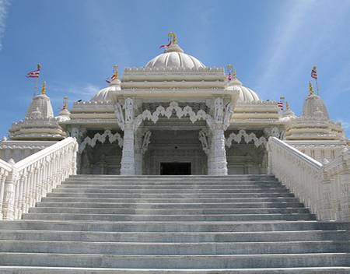  ©Flickr/Karim Rezk | Ardhamandapa  This is the porch or entrance area to a mandir, where people remove their shoes and sometimes ring a bell. It is usually reached by climbing steps which represent God’s feet. You will often see worshippers bending down to touch the steps before they enter the mandir because it is the tradition in India to touch the feet of those they respect.
  ©Flickr/duucfho | Shoe racks  People take off their shoes before they go into the mandir as another sign of respect. The inside of the temple is kept as clean as possible to symbolise the purity of God.
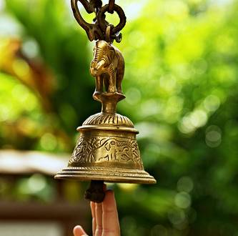  ©Flickr/Spodeworld | Bell  As people enter, they will often ring a bell. They are announcing their arrival to the deities inside, just as you would knock on someone’s front door or ring the doorbell. It’s the respectful thing to do, because Hindus believe you are entering God’s house.
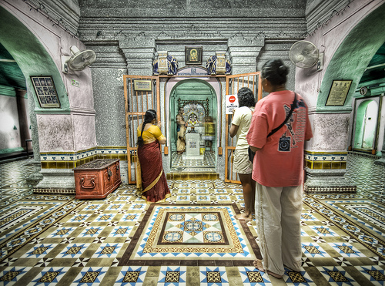  ©Flickr/Stuck in Customs | Mandapa  This is the main prayer hall of the temple, and it represents a body. It often has lots of pillars to symbolise bones. There are usually various shrines dedicated to different Gods around the mandapa, with a main shrine at the front.
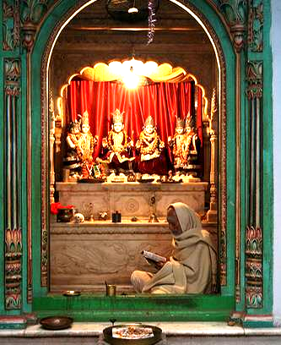  ©Flickr/Mellagi | Garbha Griha  The main shrine is called a garbha griha which means “womb house”. It symbolises the womb or heart of the body because it gives life to the whole temple. Inside this shrine will be statues and pictures of the deities that the mandir is dedicated to. There is a corridor or a space left all around the garbha griha called a pradakshina. This is so that people can walk all the way round the shrine in a clockwise direction, keeping the shrine on their right hand side. It shows that, just as the shrine is at the centre of the circle they make as they walk, God is at the centre of their lives.
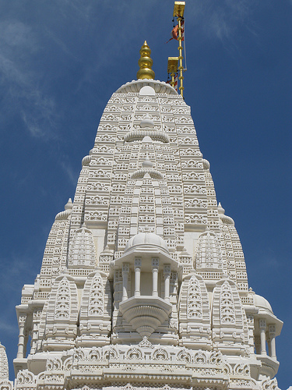  ©Flickr/Karim Rezk | Shikara  On the roof of the mandir, above the main shrine, there might be an elegant spire called a shikara. This represents the head of the body, and the flags on top represent hair. Some mandirs have several shikaras above all the different shrines. They point upwards to symbolise the journey of the soul up to God. They also represent the Himalayas – the mountains in India where the Gods were traditionally believed to live. In fact “shikara” means “mountain peak”. The colour of the flags show which deity the temple is dedicated to, so an orange flag means the mandir is dedicated to Shiva, a red and white striped flag shows that it is dedicated to Swaminarayan.
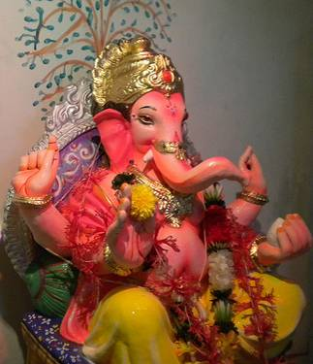  ©Flickr/Ishan Manjrekar | Murti  A murti is an image of a deity. Hindus use images of the different Gods and Goddesses to help them worship. They are treated as honoured guests, and will be washed, decorated and given offerings of food every day as signs of respect to the deities they symbolise. Each one of the deities represents one aspect of the personality of the one unseen God – Brahman. No matter which deity the temple is dedicated to, it is traditional to have a murti of the elephant-headed God Ganesha on the left of the door as you enter.
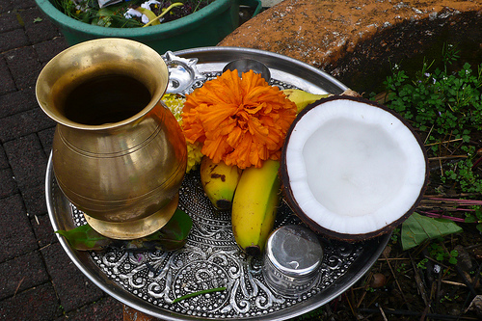  ©Flickr/Katchooo | Puja Tray  Puja is the Hindu name for “worship” or “prayer”. A tray is often laid out with various objects that will help Hindus in their worship: fruit, rice, flowers, water, a lamp, coloured powders, incense, a bell - there will be items to touch, taste, smell, hear and look at. All five senses are involved as a symbol that the whole person is devoted to God.
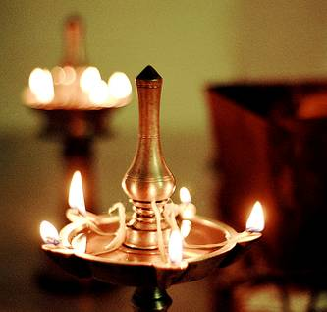  ©Flickr/Premshree Pillai | Arti Lamp  The arti is a ceremony in which light is offered to the murtis. The Priest will use a lamp with five wicks to symbolise the five traditional elements of earth, air, fire, water and space. The lamp is blessed by God during the arti prayer and then it is offered to the worshippers who pass their hand over the flames and then touch the heads as to show that they want to receive God’s blessing and enlightenment.
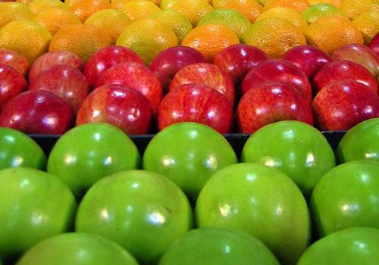  ©Flickr/justinknol | Prasad  Prasad is food that is offered to the murtis and then shared out to the worshippers after puja. Hindus believe that God blesses the food during the prayers, and that by eating the prasad, they receive his blessing. Fruit, nuts and sweets are popular forms of prasad.
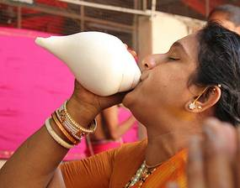  ©Flickr/exbinito | Conch Shell  It is possible to blow into a conch shell like a trumpet, and it is often used in worship, accompanied by the ringing of bells and the banging of drums. Murtis of Vishnu, can be seen holding a conch shell which symbolises that God brings life out of water.
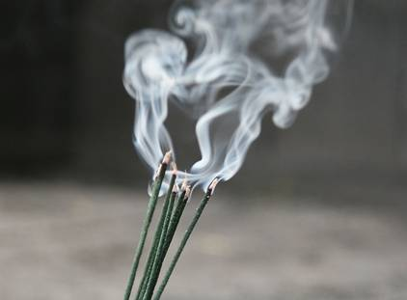  ©Flickr/whitecat singapore | Incense  Incense is burned in temples and around shrines in Hindu homes to purify the air, hiding any nasty smells. It also creates an atmosphere that Hindus have grown up associating with worship, so it helps to get them in the right frame of mind.
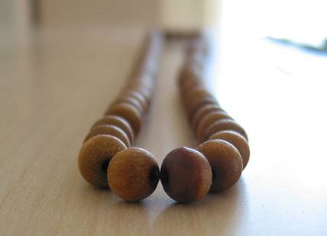  ©Flickr/moxlux | Mala Beads  Many religions use prayer beads to that people can use the sense of touch to help them worship. Hindus use a string of 108 beads called a mala. 108 is a holy number in many eastern religions. Worshippers pass the beads through their fingers, and for each one they recite a short prayer called a mantra or one of God’s names.
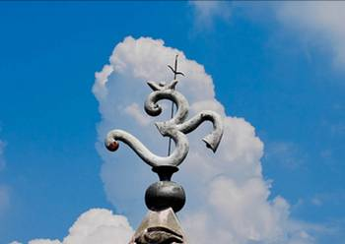  ©Flickr/himagni | Symbols  Mandirs are decorated with many different symbols including: the Om (or Aum - left) which represents the one unseen God; the lotus flower which symbolises purity and beauty in a polluted world; and the swastika, which represents the sun and God’s blessings, although this symbol is often misunderstood because it was used by the Nazis, turning it into a symbol of fear for many people.
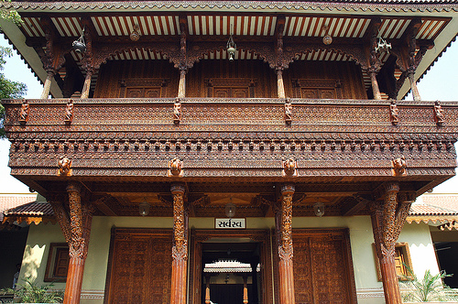  ©Flickr/chiragkpatel | Haveli  A haveli was originally a building with rooms built around a courtyard. Some mandirs have a hall or rooms attached that can be used for meetings, education classes, festivals and other events. Traditionally they are still known as havelis.
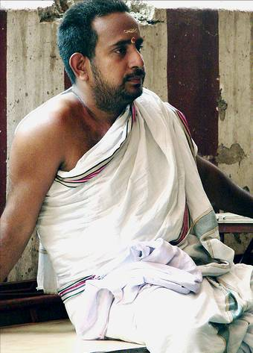  ©Flickr/calamur | Brahmin  A Hindu priest traditionally came from the Brahmin caste – the top social class - although in some forms of Hinduism, that is now not always the case. A priest might be known as a brahmin, a sadhu, a swami, a pujari or a purohit. They traditionally wear white or orange robes when they are leading puja in the temple.

Shiva Nataraja

Shiva has a third eye in the centre of his forehead – what do you think this symbolises?

Shiva has water flowing from his head
– what do you think this means?
Shiva is dancing to the beat of the drum in his hand– what could this symbolise?

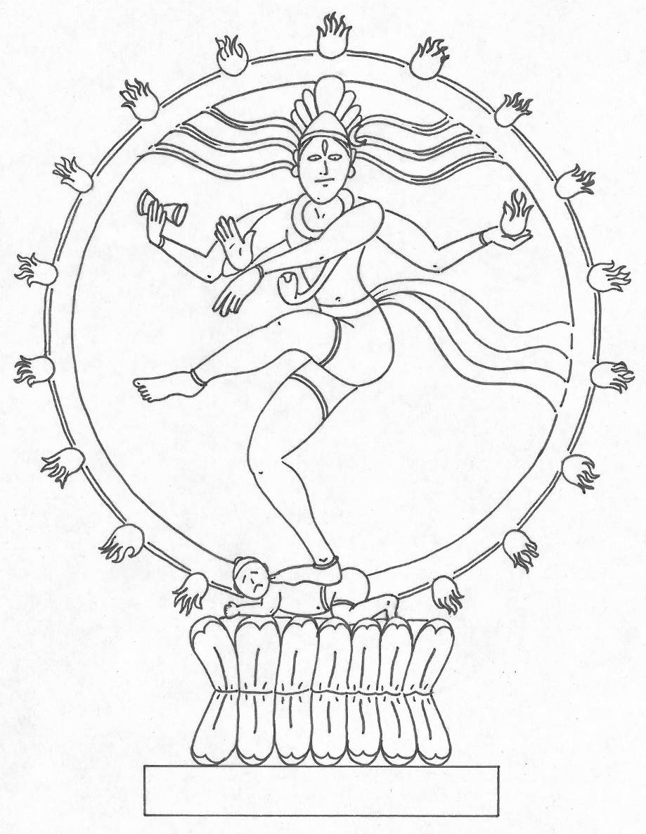
Shiva is dancing on a demon – what does this tell us about him?
Shiva is holding a ball of flame
– what could this symbolise?
Shiva has a cobra around his neck – what do you think this means?
One hand is held up towards us – why do you think Shiva is doing this?

What other things do you notice in this image of Shiva?
What do you think they mean?
What else does this image tell us in regarding Hindu beliefs about God?
Shiva Nataraja

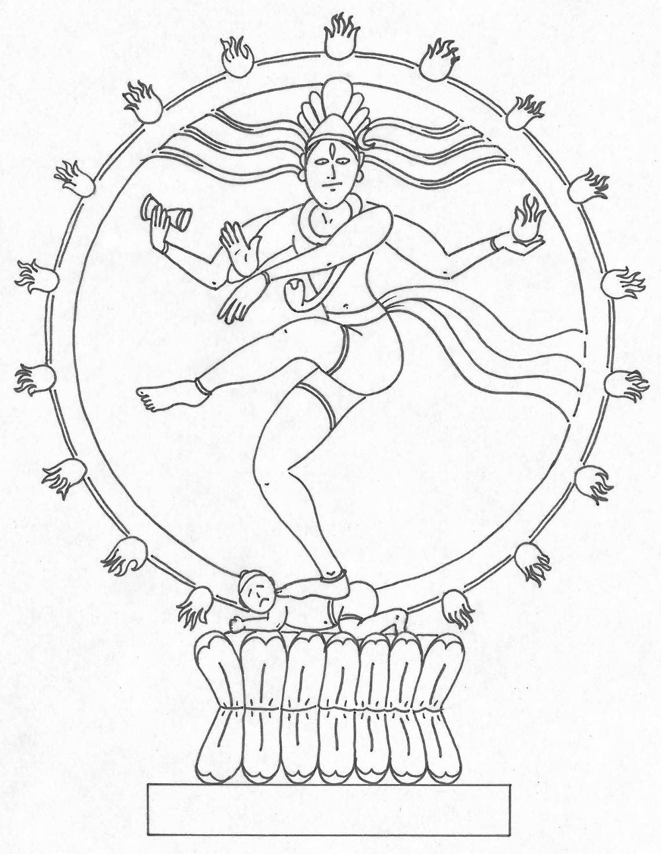

Shiva - Nataraja

Nataraja means “Lord of the Dance” or even “King of the Dancers”. Many Hindu beliefs about God are symbolised by this image of Shiva.

The Dance and the Dancer

You cannot see a dance without a dancer performing it. Take the dancer away, and the dance would no longer exist. In the same way Hindus believe that God created the world and that he continues to be a part of it. Without God, creation would cease to exist.

Circle of Fire

The circle of flame around Shiva symbolises the universe we live in. God is at the centre, with the stars, planets and moons all in motion around him. The circle represents the never-ending cycle of birth, life, death and re-birth; or the creation, preservation, destruction and re-creation that God powers. Without him, none of it would happen – the whole process is kept in perfect balance by God. He is all-powerful, and all power comes from him.

Drum

In Shiva’s upper right hand he is holding a little drum in the shape of an hour glass. This symbolises his power to create. It is the beat of time, the rhythm of life – the noise of language, music, stories and knowledge that God brings into being.

Fire

In Shiva’s upper left hand he is holding a ball of flame. This shows his power to destroy. He can wipe the universe clean with a purifying fire and begin all over again. In fact, Hindus believe that this has already happened many times.

Third Eye

In the centre of Shiva’s forehead there is a third eye. This is a symbol that God is all-knowing. The three eyes are also another symbol of the cycle of creation, preservation and destruction. The extra eye is the one that destroys, and so it is usually shown closed. Evil people live in fear that it will open and its gaze will fall on them in full knowledge of what they have done, and the punishment they deserve.

Water

As Shiva dances, his long hair flies out wildly on either side. From it flows the waters of the river Ganges. Water brings life and people wash in it to become clean and pure. So this symbolises that all life comes from God and that following him brings purity. Some murtis of Shiva even have a little image of Ganga – the Goddess of the river Ganges – caught in his hair.

The Crescent Moon

There is a crescent moon in Shiva’s hair. As time passes, the moon waxes and wanes. This is another symbol that God is lord of time – he is outside time and so he never changes. He is eternal.

Lotus Flower

The image of Shiva is standing on a lotus flower. This is another symbol of God’s purity. Lotus flowers have their roots in the mud of a river, and yet they float serenely on the surface, beautiful and pure. The lotus is a reminder to Hindus that even though they live in a world that can sometimes seem an evil place, they should rise above it and live good lives.

Cobra

Shiva often has a cobras coiled around his neck, arms or waist. Some say that this shows that God cannot die, because he has power over the most dangerous of creatures. Others say that the coils of the snake symbolise the cycle of birth, life, death and re-birth. Still others say that the open hood of the cobra shows that God’s power, known as “Shakti”, is fully awake and working in the universe.

Tiger Skin

Shiva is dressed in a tiger skin. In India, the tiger symbolises power, especially royal power. This shows that God is more powerful than any king. There is also a story about some men who used magic to summon up a ferocious tiger and sent it to attack Shiva. Shiva casually grabbed it and used the fingernail on his little finger to slit it down the middle and then skinned it to wear the fur.

Demon

Although it looks like Shiva is dancing on a baby, it’s actually a demon dwarf called Apasmara Purusha who represents humanity’s ignorance, lies and laziness. Shiva’s foot is stomping on it to show his victory over our worst characteristics, helping us to gain wisdom and defeat evil.

Feet

One of Shiva’s feet is firmly planted on the demon, symbolising that he is concerned with what is going on in the world. The other foot is balanced gracefully in the air, showing that we can be released from this world of suffering.

Hands

Shiva has four arms to show that he is all-powerful. The upper two hands hold creation and destruction – the drum and fire – in balance. The lower right hand is held palm forwards in a gesture that means, “Do not be afraid, I am here”. The lower left arm is in the classical Indian dance position known as “elephant hand” because it is held like an elephant’s trunk. The elephant is a symbol of the holy man in India because of its quiet strength. An elephant forges a way through the forest and people can follow its path without getting lost. This shows that people should follow God’s way through life.

